**Assignment 4 DDPG**

**Task 1: Environment Setup (Dynamic Goals and Constraints)**

class DynamicEnvironment:

    def __init__(self, size=(10, 10), max_velocity=1.0, goal_update_interval=20):

        self.size = size

        self.max_velocity = max_velocity

        self.goal_update_interval = goal_update_interval

        self.step_count = 0

        self.fig, self.ax = plt.subplots(figsize=(6, 6))

        plt.ion()

        self.reset()

    def reset(self):

        """Resets the environment to its initial state."""

        self.agent_position = np.array([np.random.uniform(0, self.size[0]), np.random.uniform(0, self.size[1])])

        self.goal_position = self._generate_new_goal()

        self.step_count = 0

        return self.agent_position, self.goal_position

    def _generate_new_goal(self):

        """Generates a new random goal position within the environment boundaries."""

        return np.array([np.random.uniform(0, self.size[0]), np.random.uniform(0, self.size[1])])

    def step(self, action):

        """Takes an action to update the environment state.

        Args:

            action (np.array): A 2D action vector representing velocity (dx, dy).

        Returns:

            tuple: (agent_position, goal_position, reward, done)

        """

        reward = -1  # Step penalty to discourage inefficiency

        # Check for exceeding maximum velocity

        if np.any(np.abs(action) > self.max_velocity):

            reward -= 10  # Penalty for exceeding velocity constraint

            action = np.clip(action, -self.max_velocity, self.max_velocity)

        # Apply velocity constraints and update agent position

        self.agent_position += action

        # Check for boundary violations

        if np.any(self.agent_position < 0) or np.any(self.agent_position > self.size):

            reward -= 5  # Penalty for moving out of bounds

            self.agent_position = np.clip(self.agent_position, 0, [self.size[0], self.size[1]])

        # Check for goal update

        self.step_count += 1

        if self.step_count % self.goal_update_interval == 0:

            self.goal_position = self._generate_new_goal()

        # Compute reward for proximity to goal

        distance_to_goal = np.linalg.norm(self.agent_position - self.goal_position)

        if distance_to_goal < 0.5:

            reward += 10  # Reward for reaching the goal

            done = True

        else:

            done = False

        return self.agent_position, self.goal_position, reward, done

    def render(self):

        """Renders the current state of the environment as a dynamic frame."""

        self.ax.clear()  # Clear the axes to update the frame

        self.ax.set_xlim(0, self.size[0])

        self.ax.set_ylim(0, self.size[1])

        self.ax.plot(self.agent_position[0], self.agent_position[1], 'bo', label='Agent')

        self.ax.plot(self.goal_position[0], self.goal_position[1], 'ro', label='Goal')

        self.ax.legend()

        self.ax.set_title("Environment State")

        plt.pause(0.1)

    def close(self):

        """Closes the rendering window."""

        plt.ioff()  # Turn off interactive mode

        plt.show()

**Task 2: DDPG Algorithm Implementation**

class ReplayBuffer:

    def __init__(self, max_size, input_shape, n_actions):

        """

        Initialize the replay buffer.

        Args:

        - max_size (int): Maximum number of transitions the buffer can store.

        - input_shape (tuple): Shape of the state space (e.g., (state_dim,)).

        - n_actions (int): Number of actions in the action space.

        Attributes:

        - max_size: Maximum buffer size.

        - mem_cntr: Counter to keep track of the number of transitions added.

        - state_memory: Array to store states.

        - new_state_memory: Array to store the next states.

        - action_memory: Array to store actions taken.

        - reward_memory: Array to store rewards received.

        - terminal_memory: Array to store terminal flags (whether the episode ended).

        """

        self.max_size = max_size

        self.mem_cntr = 0  # Initialize the memory counter to 0

        # Initialize memory arrays

        self.state_memory = np.zeros((self.max_size, input_shape))  # Stores states

        self.new_state_memory = np.zeros((self.max_size, input_shape))  # Stores next states

        self.action_memory = np.zeros((self.max_size, n_actions))  # Stores actions

        self.reward_memory = np.zeros(self.max_size)  # Stores rewards

        self.terminal_memory = np.zeros(self.max_size, dtype=np.float32)  # Stores done flags (1 - done)

    def store_transition(self, state, action, reward, state_, done):

        """

        Store a single transition in the replay buffer.

        Args:

        - state (array): Current state.

        - action (array): Action taken in the current state.

        - reward (float): Reward received after taking the action.

        - state_ (array): Next state after taking the action.

        - done (bool): Whether the episode ended after this transition.

        """

        # Find the index to store the transition (overwrites oldest transitions if full)

        index = self.mem_cntr % self.max_size

        # Store the transition components in their respective buffers

        self.state_memory[index] = state

        self.new_state_memory[index] = state_

        self.action_memory[index] = action

        self.reward_memory[index] = reward

        self.terminal_memory[index] = 1 - done  # Store 1 if not done, 0 if done

        # Increment the memory counter

        self.mem_cntr += 1

    def sample_buffer(self, batch_size):

        """

        Sample a batch of transitions from the replay buffer.

        Args:

        - batch_size (int): Number of transitions to sample.

        Returns:

        - states (array): Batch of sampled states.

        - actions (array): Batch of sampled actions.

        - rewards (array): Batch of sampled rewards.

        - states_ (array): Batch of sampled next states.

        - dones (array): Batch of sampled terminal flags (1 - done).

        """

        # Determine the maximum number of stored transitions

        max_mem = min(self.mem_cntr, self.max_size)

        # Randomly sample `batch_size` indices from the range [0, max_mem)

        batch = np.random.choice(max_mem, batch_size, replace=False)

        # Retrieve the sampled transitions using the indices

        states = self.state_memory[batch]

        states_ = self.new_state_memory[batch]

        actions = self.action_memory[batch]

        rewards = self.reward_memory[batch]

        dones = self.terminal_memory[batch]

        return states, actions, rewards, states_, dones

# Critic Network

class Critic(nn.Module):

    def __init__(self, beta, input_dims, fc1_dims, fc2_dims, n_actions, name, chkpt_dir = 'tmp/ddpg'):

        super(Critic, self).__init__()

        self.input_dims = input_dims

        self.fc1_dims = fc1_dims

        self.fc2_dims = fc2_dims

        self.n_actions = n_actions

        self.model_name = name

        self.checkpoint_file = os.path.join(chkpt_dir, name + '_ddpg')

        self.fc1 = nn.Linear(self.input_dims, self.fc1_dims)

        f1 = 1 / np.sqrt(self.fc1.weight.data.size()[0])

        torch.nn.init.uniform_(self.fc1.weight.data, -f1, f1)

        torch.nn.init.uniform_(self.fc1.bias.data, -f1, f1)

        self.bn1 = nn.LayerNorm(self.fc1_dims)

        self.fc2 = nn.Linear(self.fc1_dims, self.fc2_dims)

        f2 = 1 / np.sqrt(self.fc2.weight.data.size()[0])

        torch.nn.init.uniform_(self.fc2.weight.data, -f2, f2)

        torch.nn.init.uniform_(self.fc2.bias.data, -f2)

        self.bn2 = nn.LayerNorm(self.fc2_dims)

        self.action_value = nn.Linear(self.n_actions, self.fc2_dims)

        f3 = 0.003

        self.q = nn.Linear(self.fc2_dims, 1)

        torch.nn.init.uniform_(self.q.weight.data, -f3, f3)

        torch.nn.init.uniform_(self.q.bias.data, -f3, f3)

        self.optimizer = optim.Adam(self.parameters(), lr=beta, weight_decay=0.01)

        self.device = T.device('cuda:0' if T.cuda.is_available() else 'cpu')

        self.to(self.device)

    def forward(self, state, action):

        state = state.to(self.device) # Ensure input is on the same device as the model

        action = action.to(self.device)

        state_value = self.fc1(state)

        state_value = self.bn1(state_value)

        state_value = F.relu(state_value)

        state_value = self.fc2(state_value)

        state_value = self.bn2(state_value)

        action_value = F.relu(self.action_value(action))

        state_action_value = F.relu(T.add(state_value, action_value))

        state_action_value = self.q(state_action_value)

        return state_action_value

    def save_checkpoint(self):

        print("....Saving Checkpoint....")

        T.save(self.state_dict(), self.checkpoint_file)

    def load_checkpoint(self):

        print("....Loading Checkpoint....")

        checkpoint = T.load(self.checkpoint_file, map_location=T.device('cpu'))  # Load the checkpoint

        self.load_state_dict(checkpoint)  # Update the model with the loaded state_dict

# Actor Network

class Actor(nn.Module):

    def __init__(self, alpha, input_dims, fc1_dims, fc2_dims, n_actions, name, chkpt_dir = 'tmp/ddpg'):

        super(Actor, self).__init__()

        self.input_dims = input_dims

        self.fc1_dims = fc1_dims

        self.fc2_dims = fc2_dims

        self.n_actions = n_actions

        self.model_name = name

        self.checkpoint_file = os.path.join(chkpt_dir, name + '_ddpg')

        self.fc1 = nn.Linear(self.input_dims, self.fc1_dims)

        f1 = 1 / np.sqrt(self.fc1.weight.data.size()[0])

        T.nn.init.uniform_(self.fc1.weight.data, -f1, f1)

        T.nn.init.uniform_(self.fc1.bias.data, -f1, f1)

        self.bn1 = nn.LayerNorm(self.fc1_dims)

        self.fc2 = nn.Linear(self.fc1_dims, self.fc2_dims)

        f2 = 1 / np.sqrt(self.fc2.weight.data.size()[0])

        T.nn.init.uniform_(self.fc2.weight.data, -f2, f2)

        T.nn.init.uniform_(self.fc2.bias.data, -f2, f2)

        self.bn2 = nn.LayerNorm(self.fc2_dims)

        f3 = 0.003

        self.mu = nn.Linear(self.fc2_dims, self.n_actions)

        T.nn.init.uniform_(self.mu.weight.data, -f3, f3)

        T.nn.init.uniform_(self.mu.bias.data, -f3, f3)

        self.optimizer = optim.Adam(self.parameters(), lr=alpha, weight_decay=0.01)

        self.device = T.device('cuda:0' if T.cuda.is_available() else 'cpu')

        self.to(self.device)

    def forward(self, state):

        state = state.to(self.device)

        x = self.fc1(state)

        x = self.bn1(x)

        x = F.relu(x)

        x = self.fc2(x)

        x = self.bn2(x)

        x = T.tanh(self.mu(x))

        return x

    def save_checkpoint(self):

        print("....Saving Checkpoint....")

        os.makedirs(os.path.dirname(self.checkpoint_file), exist_ok=True)

        T.save(self.state_dict(), self.checkpoint_file)

    def load_checkpoint(self):

        print("....Loading Checkpoint....")

        checkpoint = T.load(self.checkpoint_file, map_location=T.device('cpu'))  # Load the checkpoint

        self.load_state_dict(checkpoint)  # Update the model with the loaded state_dict

class Agent():

  def __init__(self, alpha, beta, input_dims, tau, env, gamma = 0.99, n_actions = 2, max_size = 1000000, layer1_size = 400, layer2_size = 300, batch_size = 64):

    self.gamma = gamma

    self.tau = tau

    self.memory = ReplayBuffer(max_size, input_dims, n_actions)

    self.batch_size = batch_size

    self.actor = Actor(alpha, input_dims, layer1_size, layer2_size, n_actions = n_actions, name = 'Actor')

    self.target_actor = Actor(alpha, input_dims, layer1_size, layer2_size, n_actions = n_actions, name = 'TargetActor')

    self.critic = Critic(beta, input_dims, layer1_size, layer2_size, n_actions = n_actions, name = 'Critic')

    self.target_critic = Critic(beta, input_dims, layer1_size, layer2_size, n_actions = n_actions, name = 'TargetCritic')

    self.noise = OUActionNoise(mu = np.zeros(n_actions))

    self.update_network_parameters(tau = 1)

  def choose_action(self, observation):

    self.actor.eval()

    observation = T.tensor(observation, dtype = T.float).to(self.actor.device)

    mu = self.actor.forward(observation)

    mu_prime = mu + T.tensor(self.noise(), dtype = T.float).to(self.actor.device)

    self.actor.train()

    return mu_prime.cpu().detach().numpy()

  def remember(self, state, action, reward, new_state, done):

    self.memory.store_transition(state, action, reward, new_state, done)

  def learn(self):

    if self.memory.mem_cntr < self.batch_size:

      return

    state, action, reward, new_state, done = self.memory.sample_buffer(self.batch_size)

    reward = T.tensor(reward, dtype = T.float).to(self.critic.device)

    done = T.tensor(done).to(self.critic.device)

    new_state = T.tensor(new_state, dtype = T.float).to(self.critic.device)

    action = T.tensor(action, dtype = T.float).to(self.critic.device)

    state = T.tensor(state, dtype = T.float).to(self.critic.device)

    self.target_actor.eval()

    self.target_critic.eval()

    self.critic.eval()

    target_actions = self.target_actor.forward(new_state)

    critic_value_ = self.target_critic.forward(new_state, target_actions)

    critic_value = self.critic.forward(state, action)

    target = []

    for j in range(self.batch_size):

      target.append(reward[j] + self.gamma*critic_value_[j]*done[j])

    target = T.tensor(target).to(self.critic.device)

    target = target.view(self.batch_size, 1)

    self.critic.train()

    self.critic.optimizer.zero_grad()

    critic_loss = F.mse_loss(target, critic_value)

    critic_loss.backward()

    self.critic.optimizer.step()

    self.critic.eval()

    self.actor.optimizer.zero_grad()

    mu = self.actor.forward(state)

    self.actor.train()

    actor_loss = -self.critic.forward(state, mu)

    actor_loss = T.mean(actor_loss)

    actor_loss.backward()

    self.actor.optimizer.step()

    self.update_network_parameters()

  def update_network_parameters(self, tau = None):

    if tau is None:

      tau = self.tau

    actor_params = self.actor.named_parameters()

    critic_params = self.critic.named_parameters()

    target_actor_params = self.target_actor.named_parameters()

    target_critic_params = self.target_critic.named_parameters()

    critic_state_dict = dict(critic_params)

    actor_state_dict = dict(actor_params)

    target_critic_state_dict = dict(target_critic_params)

    target_actor_state_dict = dict(target_actor_params)

    for name in critic_state_dict:

      critic_state_dict[name] = tau*critic_state_dict[name].clone() + (1-tau)*target_critic_state_dict[name].clone()

    self.target_critic.load_state_dict(critic_state_dict)

    for name in actor_state_dict:

      actor_state_dict[name] = tau*actor_state_dict[name].clone() + (1-tau)*target_actor_state_dict[name].clone()

    self.target_actor.load_state_dict(actor_state_dict)

  def save_models(self):

    self.actor.save_checkpoint()

    self.target_actor.save_checkpoint()

    self.critic.save_checkpoint()

    self.target_critic.save_checkpoint()

  def load_models(self):

    self.actor.load_checkpoint()

    self.target_actor.load_checkpoint()

    self.critic.load_checkpoint()

    self.target_critic.load_checkpoint()

**Plot of Rewards Vs. Episodes**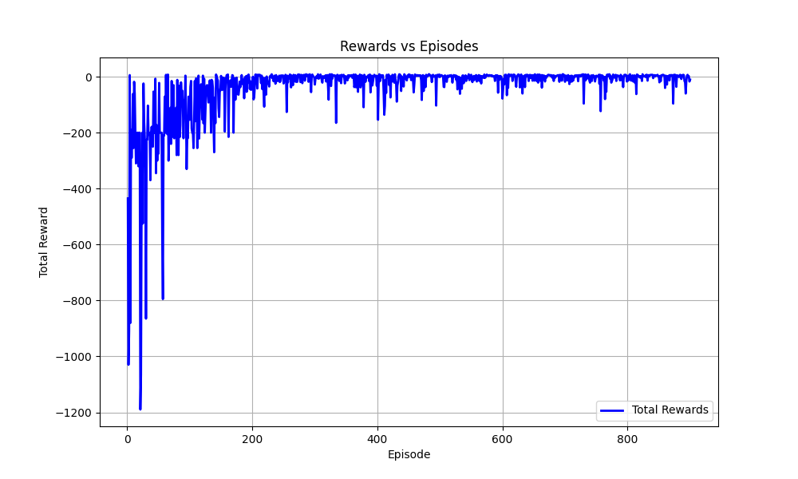

**Task 3: Advanced Evaluation and Analysis**

The trained agent works well with dynamically changing goal positions.

But, it accumulates a lot of penalty when the max velocity constraints are modified from (1,1) to (0.5,0.5). This happens as the agent was trained on a different velocity constraint.

The agent has a success rate of 99.2%(calculated for 500 episodes),   
The average steps taken by the agent are 13.

Visualization uploaded to google drive…

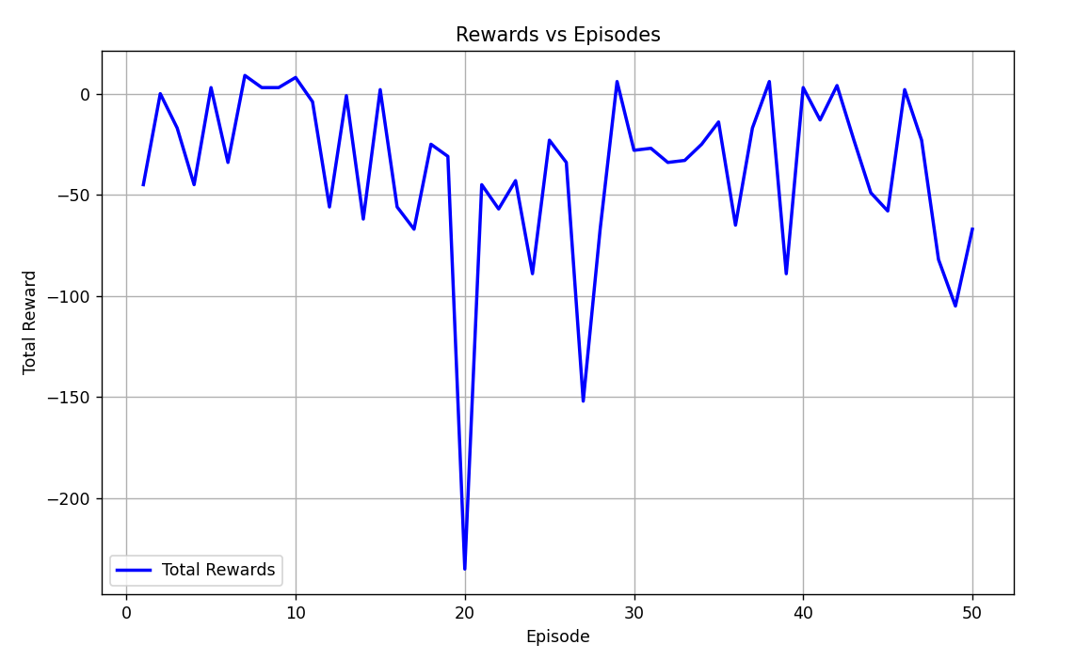

**Trying to implement an obstacle:**

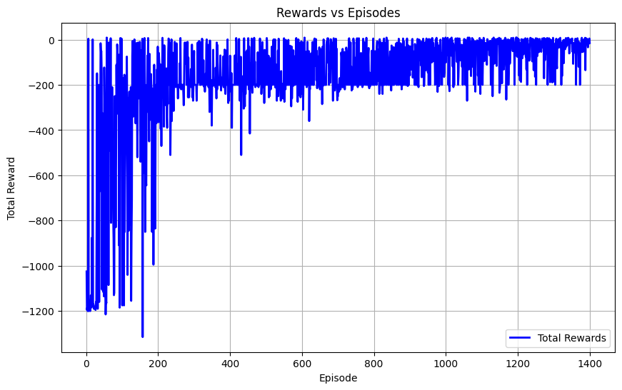

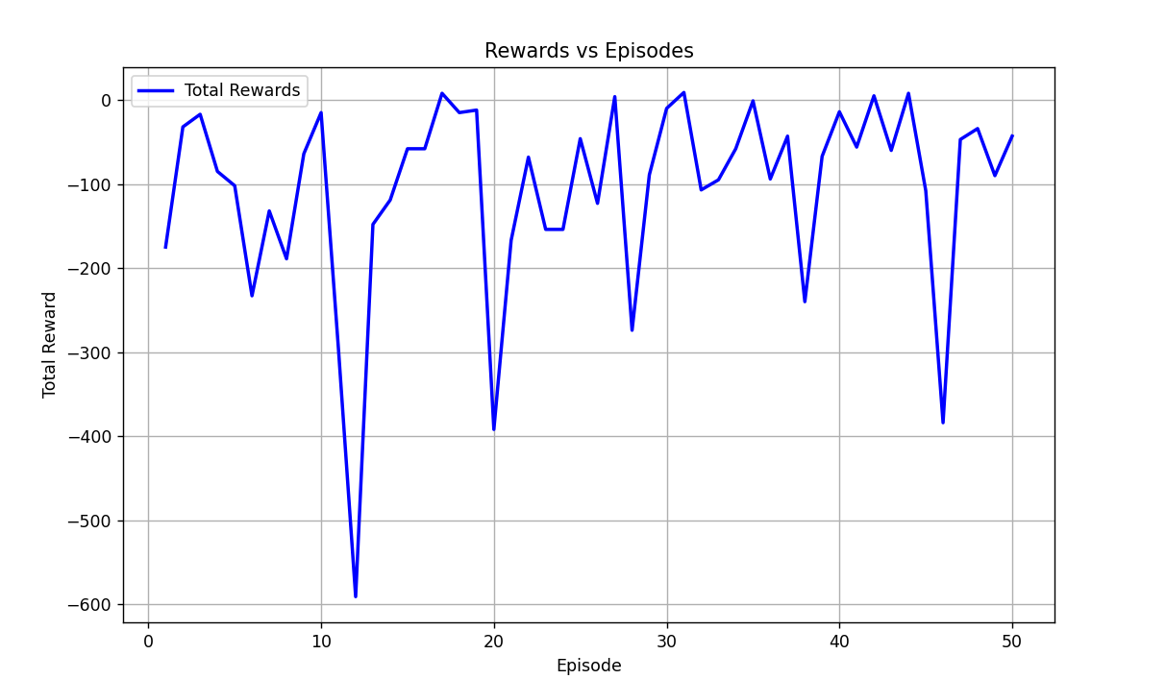

This model was trained with 1 obstacle that changes positions dynamically every 20 steps. It is observed that the agent is able to navigate while avoiding the obstacle but the training time was greatly increased(by a factor of 5x). It is also observed that the agent would oscillate near the goal accumulating negative reward for a few steps before actually reaching the goal(I was unable to find the reason.)